Coconut Termite | Extension Fact Sheet | 116

Common names: Coconut termite, Rainbow termite
Scientific name: Neotermes rainbowi.
Hosts: Coconuts mainly, but also the stilt roots of Pandanus; reports that it attacks other trees may be due to misidentifications.
Distribution: Known only from the central Pacific. It is present in many atoll countries, and thought to be present in Fiji (Rotuma group) and Tonga. Note, the presence of N. rainbow in Fiji is questioned by Waterhouse: a) citrus and cocoa are attacked which is unusual, and b) the net-like grooves in the bark are not reported.

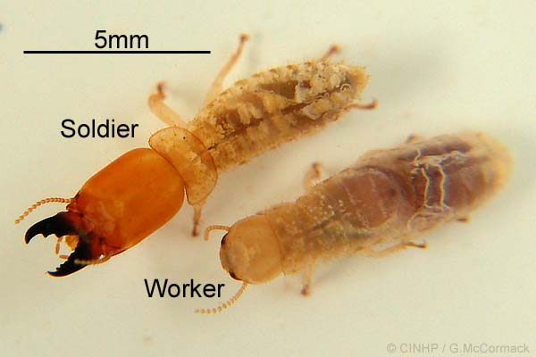
Damage
The termites (photo, above²) hollow out living trunks leading to the top of the palm snapping off, even in the relatively low force of the tradewinds. The yield of young palms may also be reduced, and they may be killed before they bear coconuts. The termite workers make holes and grooves on the surface of coconuts, and these are characteristic of N. rainbowi (photo, below²), and unlike other species; later, these form a net-like pattern from soil level to several metres. The grooves, which extend to the depth of the bark are covered with chips of wood and bark mixed with faecal matter.

The insides of the trunk are also attacked, and the hollowing that occurs leads to the loss of the tops of the palm. These hollows are filled with tunnels of faecal and other matter. In some places the termites spread from the infestation through roots and soil to neighbouring palms.

In communities where coconut has high social and economic importance, this is a serious pest.
Biology and Life Cycle
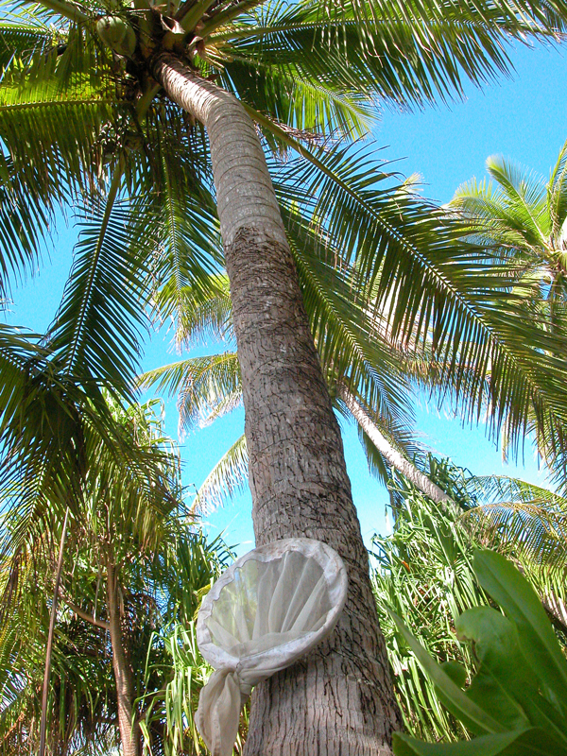
Neotermes species are classified as live-wood termites, meaning they attack living trees. They are considered to be primitive termites. The life cycle starts with a nuptial flight and a male and female establishing a colony in a suitable tree, entering through a crack or wound, or chewing their way in. After mating, the female stats laying eggs, which mostly become workers, and a few soldiers (photo, above²). These feed and tend the king and queen, more eggs are laid and the colony grows. Colonies may last for more than 20 years. Kings and queens can be replaced from immatures should they be injured or die.

The function of the grooves (photo, right²) in the coconut bark is not known, but several possibilities are suggested: moisture control, temperature regulation or conditioning of the wood beneath.
Detection and Inspection
Look for the net-like grooves covered with a mix of wood and faecal matter within the bark of coconuts; these channels are characteristic for the species. Look for hollowed out stumps.
Management
Natural enemies
There are many natural enemies, including ants and many predatory insects, but also mites, birds, lizards, snakes, frogs, fungi, and nematodes. Mostly, they hasten the demise of already weakened colonies, and have limited potential as biological control agents. Ants are probably the most important factor preventing the spread of the termite, but it is not recommended that they are introduced to islands infested with Neotermes to reduce populations or even eliminate them. Any introduced ants are more than likely to become pest later.
Cultural control
- Remove and burn infested coconuts palms as soon as the telltale net-like grooves are seen on the bark.
Resistant varieties
No varieties of coconuts are resistant as far as is known.
Chemical control
Insecticides are not recommended and should not be used, especially where contamination of the water table is a possibility; arsenic, lindane, dieldren and others, which are now banned worldwide, have been used in the past.
Biopesticides. Selected strains of Metarhizium anisopliae and an entomopathogenic nematode, Heterorhabditis sp. have been tried in Tuvalu by injecting them into termite nests, and have given promising results.

Much of the information given here comes from Waterhouse DF (1993) Biological Control Pacific Prospects – Supplement 2. ACIAR Monograph No. 20. Brown Anderson, Burwood, Victoria. 2 Photos of soldier and worker (above), and grooves in bark (below) made by Neotermes rainbowi (Gerald McCormak, Cook Island Biodiversity & Natural Heritage: http://cookislands.bishopmuseum.org/)

